Dim_Date:

Dim_Customers

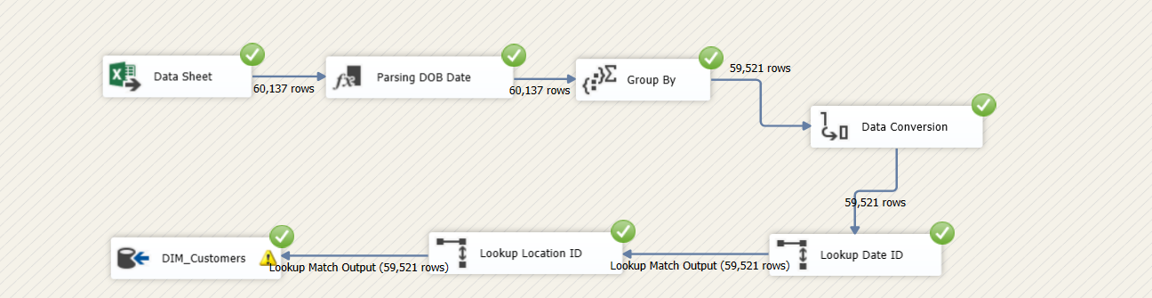

Dim_Transaction_Type

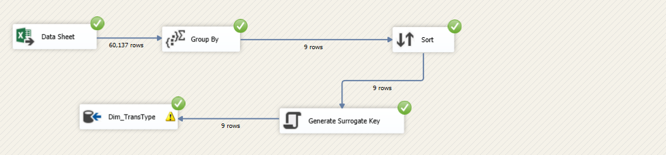

Fact_Transactions:

